

DEPARTMENT OF COMPUTER SCIENCE – UBIT

“Assembly language”

CSSE – 403

Chaudhary Usama Ishtiaq

Section ‘A’ (EVENING)

EB23210106023

Submitted to: SIR FAROOQ

ASSIGNMENT-07

**LAB: 07**

**Objective**: Write a program that takes sequence of characters as input and display it in reverse order in new line. Output will be: User Input: UOK-UBIT User Input in reverse order: TIBU-KOU.**­Input:**

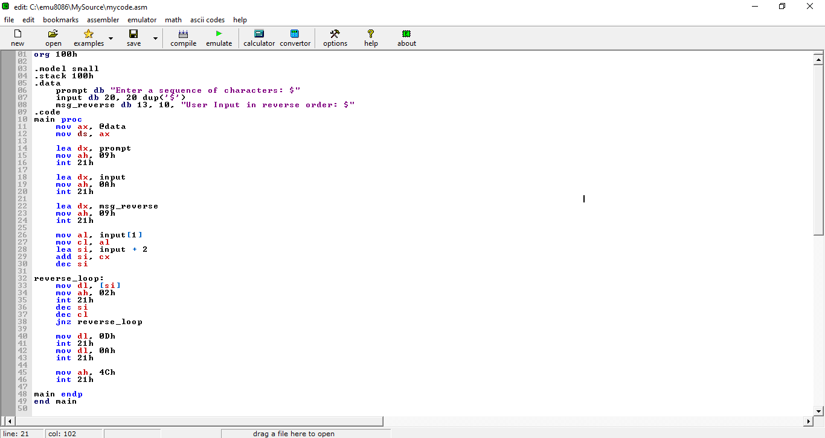

**Output:**

